**QA Helper Instructions**

**Setup & Installation**

1. Download the QA-Helper zip file from Sharepoint.
2. Open the QA-Helper folder and double click the **Install** file.
   1. This will automatically add the QA-Helper to your bookmarks tab in the Chrome browser.

***Note:*** If you open up Chrome and all your tabs are missing, **DO NOT** click the install file again. Instead, double click the “Restore” file in the QA-Helper folder. This will restore all of your bookmarks. **PLEASE CONTANCT JORDIN OR MITCHELL IF THIS HAPPENS TO YOU.**

**Using the Tool**

1. Login to [uti.blackboard.com](https://uti.blackboard.com/).
2. Click on the link under the “My Courses” tab

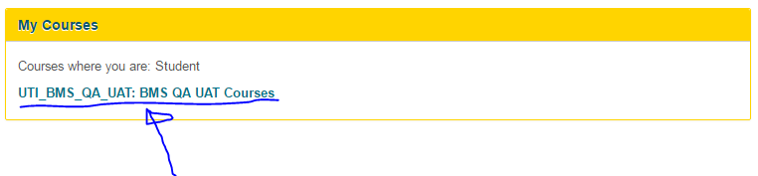

1. Click on the “Content” tab on the left side of the page

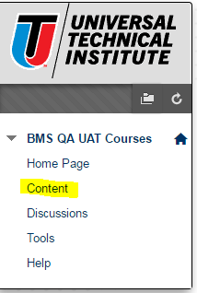

1. Choose the desired course and then choose the desired IOL (Interactive Online Learning)

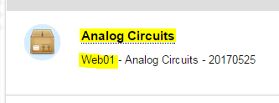

1. A new window will pop up. **Right click on the top bar** of the window and click “Show as Tab”

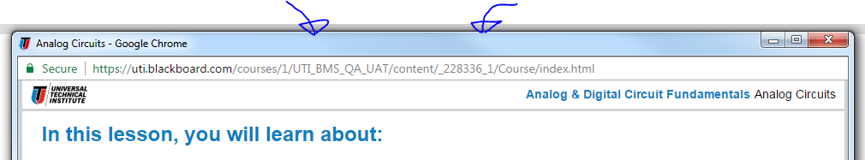

1. Click on the **“QA Helper”** bookmark at the top of Google Chrome (If the QA Helper tab does not show up on the bar, click the first “Folder” bookmark  from the left side of the bar to see if QA Helper is inside it. When found, drag QA Helper to the main bookmarks bar.)

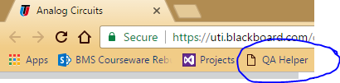

1. A new TFS (Team Foundation Server) window should pop up (move this new TFS page to another monitor for best user experience). **Click “Projects”** on the left side of the TFS window.

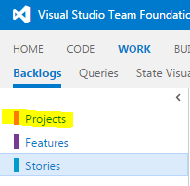

1. Click the QA Helper bookmark on this new TFS page. **THIS IS ESSENTIAL.**
2. Open the correct **Project** and **Feature** (same as the ones you chose in steps 4 & 5 – Web Numbers may be different).
3. Make sure the “**Content QA**” User Story is visible on the screen.

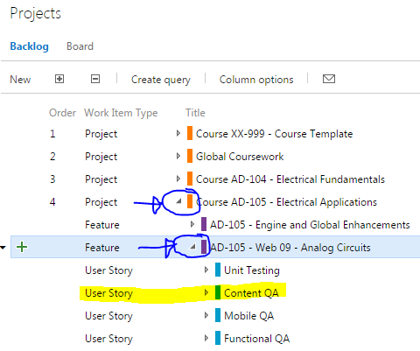

1. You are now ready to use the UTI QA Helper. Click **Add Bug** on the Blackboard slide to open a new bug in the TFS window. You can drag the QA Helper wherever is most convenient.

***Note:*** You can also navigate between slides, using the Previous Slide and Next Slide buttons, but this is only recommended if you are unable to move on from a certain slide. Using these buttons bypasses the normal functionality of the slides. If you bypass the functionality, you may not be able to test the functionality as expected.